**JavaScript Alerts Adding Behaviors to Website**

Open browser inspect by **ctrl+shift+I** and go to console and write alerts like alert(“Hello”);

Open developer tool by pressing **ctrl+shift+j**

And see messages like

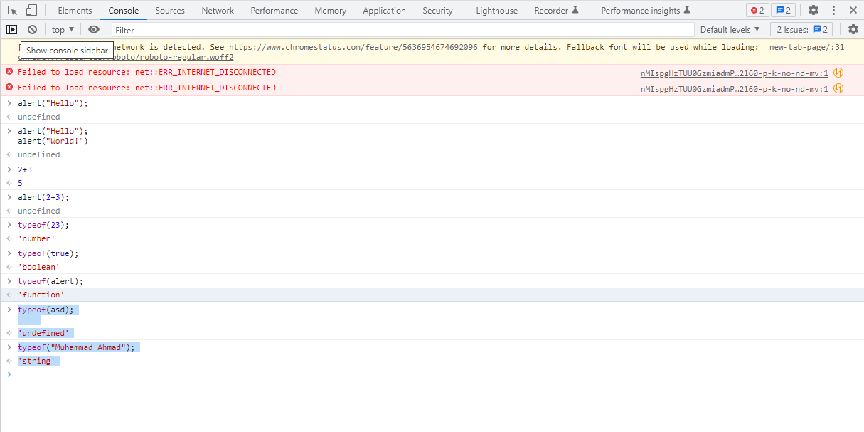

Shift+Enter to add two alerts like **“Hello” “World!”**

Above errors are due to offline (no internet). See data types like **number, string , function etc.**



Open this website and explore things.

Also open below website.

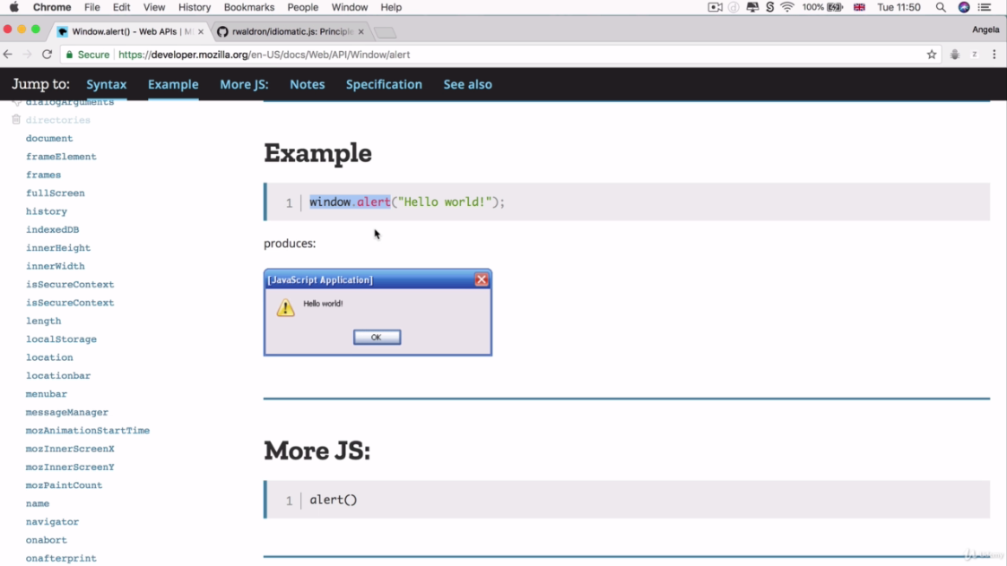

<http://developer.mozilla.org/en-US/docs/Web/window/alert>

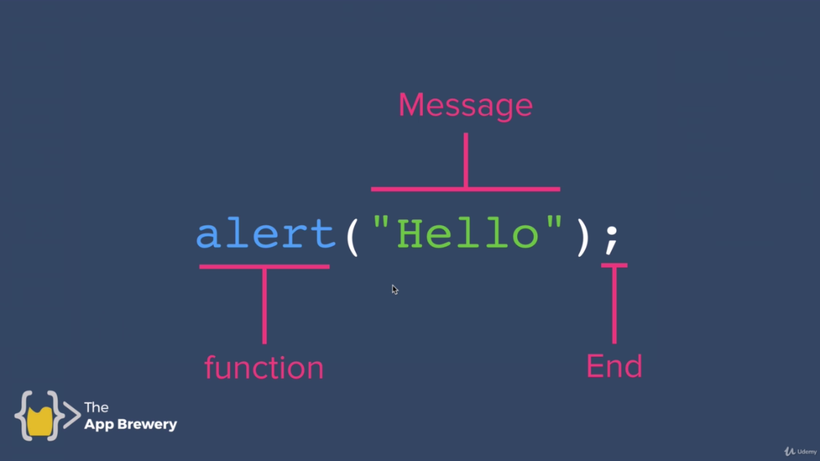

Alerts Syntax:

<function><message>end

alert(“String”);

**Note:** strings are written in single/double strings.

alert(“Hello”); It is like a say **“Hello”.** as we use in English sentence.

<http://github.com/rwaldron/idiomatic.js#naming>

<http://en.wikipedia.org/wiki/The_Elements_of_Style>

<http://github.com/rwaldron/idiomatic.js#naming>

explore above websites